The West Midlands is home to a growing and diverse migrant population. In Birmingham, approximately 250,000 people were born outside the UK and 12% of the total number of asylum seekers in the UK currently claiming support whilst awaiting a decision on their status are resident in the wider West Midlands region. Local authorities across the region are committed to creating an inclusive environment for everyone who is a refugee or migrant and the work of the voluntary and community sectors provides a vital component of this strategy.
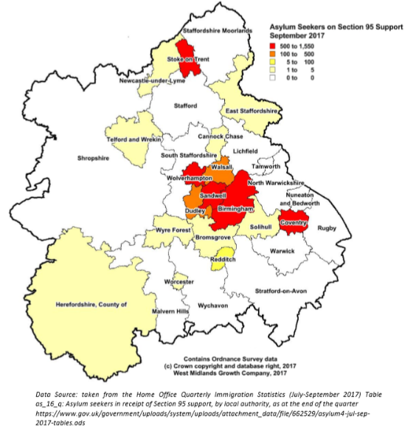
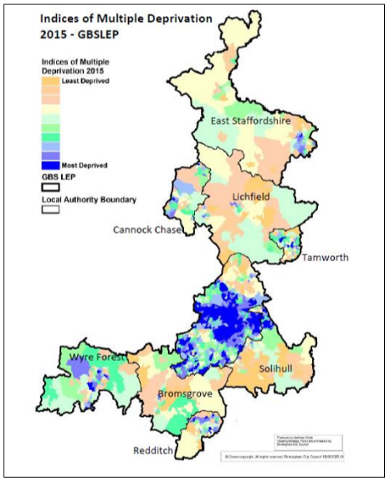
Despite its importance and impact, voluntary and community sector activity which works with and supports refugee and migrant communities remains underfunded. Recent analysis has indicated that less than 1% of all independent funding within the sector is directed specifically towards these communities. The impression given is that this type of activity is viewed as specialist, attracting only dedicated funders and service provision. However, the successful support of refugee and migrant communities can have a positive impact upon wider societal issues.
Many people who are refugees and migrants in the region are resident within areas of high deprivation and investment in their support can provide associated benefits to other marginalised groups also living in these areas
.

People are who are refugees and migrants coming to the UK and the region have aspirations to create new and successful lives, however systemic barriers can provide significant barriers to achieving this. One of the major issues identified by the voluntary sector is a lack of access to specialist rights based legal advice. This increases the vulnerability of people who are refugees and migrants, leaving them unable to regularize their status and creating the conditions for destitution and homelessness to replace hope and aspiration. Indeed, people who are refugees are classed as one of the groups thought to be at greatest risk of becoming homeless.
This briefing is the first in a series commissioned by voluntary sector organisations working with refugee and migrant communities in the West Midlands. It is intended to highlight current areas of where investment can have a significant impact on the resettlement and integration of people arriving in the region, as well as wider community cohesion.
Lack of Free Specialist and Regulated Advice: People who are refugees and migrants can enter the UK as a result of difficult circumstances with complex legal cases in order to resolve their immigration status. These require specialist advice, which for many remains outside the scope of legal aid funding. Such advice can only be provided by properly accredited individuals, with regional voluntary organisations assisting many of those in need of support to progress their cases.
The number of referrals vastly exceeds capacity within the sector and there is an urgent need for greater provision. The situation is likely to be exacerbated by further cases of long-term UK residents from the Windrush generation as well as the ongoing uncertainty over any post-Brexit settlement. It is also creating an ever growing population of people with “No Recourse to Public Funds” at significant risk of destitution.
ASIRT, a local legal advocacy organisation, provide support and representation to those not eligible for publically funded representation. Their clients encounter issues with the cost of visa applications and legal fees which for those in low wage employment or precarious financial situations present major barriers in obtaining regularised status in the UK
The Birmingham Community Law Centre provides free legal advice to those who cannot afford a lawyer and is attempting to increase the provision of Legal Aid immigration advice through its Exceptional Case Funding clinic in collaboration with Birmingham City University students.
From Crisis to Prevention: Early access to specialist advice can have a positive effect upon wider social issues. Barriers between the voluntary and statutory sectors mean that those seeking support are already at a point of crisis, seeking to resolve an immediate issue. This approach does not allow the sector time or resources to address underlying issues and is also a more costly approach to supporting refugee and migrant communities than early action. Increased funding allows capacity building in the sector, a better response to long-term issues and a move towards a targeted and preventative approach. Early intervention reduces the risk of longer-term adverse social consequences, and a subsequent cost to both the individual and the state.
Refugee Action have developed the Early Action Charter to help people in the Asylum System before they reach crisis point. They have supported Sandwell based charity Brushstrokes in their work to increase contact with people new to the area, enabling them to reach vulnerable groups and to plan and foresee problems much earlier on in their asylum journey
Risk of homelessness and destitution: A lack of specialist advice relating to immigration status risks placing people who are refugees and migrants into a lengthy period of uncertainty. They can be unable to work or access training and consequently unable to provide for themselves and their families. These individuals are already in a vulnerable position upon entering the UK and this situation can be worsened as individuals can lose access to decent housing, finding themselves in low quality transient accommodation or potentially homeless.
The number of people who are refugees and migrants currently homeless impacts upon already stretched services in the region. Councils have a statutory duty to deal with homelessness, and early intervention through can prevent migrants from entering this situation and allow resources to be deployed into other vital areas.
Brushstrokes has been delivering a unique approach working alongside Sandwell Council to provide tailored support to help people manage the transition from asylum support to settled status as refugees. In 2018/19 they supported 80 refugee households. ASIRT and the Birmingham Community Law Centre have also been leading a campaign to ensure free school meal provision for the children of refugees with no recourse to public funds

Birmingham City Council, City of Sanctuary Policy Statement
http://www.wmsmp.org.uk/ - Migration Statistics Briefing Paper 28th February 2019
Graphics obtained from WMSMP Stage 1 Report and Birmingham City Council Analysis [HERE]
Birmingham City Council Homelessness Prevention Strategy 2017+
Information about ASIRT and their work can be found HERE
Asylum Early Action Programme
Further details of the Partnership and details of Brushstrokes’ work can be found HERE Details of ASIRT’s campaign around School Meal provision can be found HERE The Birmingham Community Law Centre website can be found HERE

