**West Midlands Regional Migration Network:**

**Proposed Structure**

**Version 1 – March 2022**

1. **Purpose**

The proposed Regional Migration Network will provide a forum for organisations supporting migrants across Birmingham and the Black Country to come together to agree current priorities, develop actions and discuss best practice. The Network will allow a pathway of support for migrants, helping to achieve effective settlement in the region.

1. **Challenges**

Work in the sector is varied, with organisations providing support across numerous areas of work. Resource and capacity remain a significant issue, with many unable to regularly attend forums and or develop strategic responses to address long term needs. Funding remains largely directed towards short-term crisis support.

A poll of attendees at the last Network meeting showed that for many, the highest priority issues identified in the recent Migration Sector Assessment were those linked to an Early Action response:

Lack of Housing – 11 Votes

Community Integration – 8 Votes

Employment and Training Pathways – 8 Votes

Access to Specialist Legal Advice – 8 Votes

Support for those with NRPF Conditions – 8 Votes

ESOL Provision - 7 Votes

1. **Proposal**

**The Regional Migration Network is a new structure comprised of a series of linked meetings. Administrative and secretariat support will be provided by Migration Policy and Practice staff with the involvement and collaboration of organisations and individuals within the wider VCS. Membership will be open to any group working with migrants, both specialist agencies and those working with wider client groups.**

**The structure will both inform and respond to the Sector Assessment produced annually by Migration Policy and Practice. This will support the development and delivery of strategic understanding across the regional voluntary sector.**

1. **Proposed Structure**

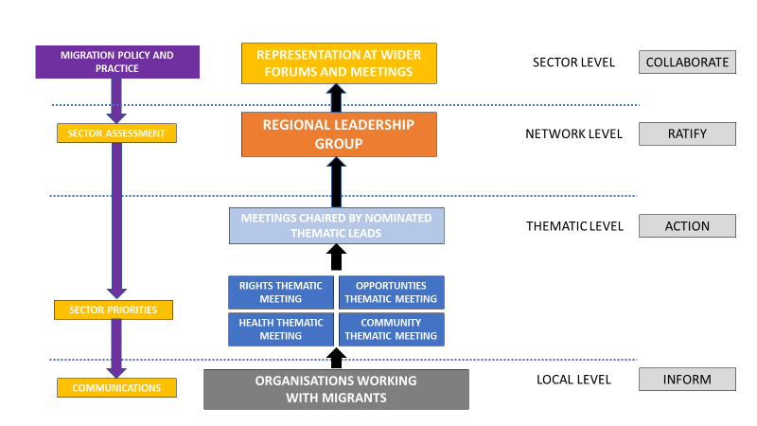

* 1. **Thematic Meetings**

It is proposed that a series of regular meetings be held structured around the four broad themes of the Project:

* Rights
* Health
* Opportunities
* Community

These can meet on a timescale agreed by the sector, initially quarterly, but with greater or lesser frequency depending on the needs of members. Attendance is open to any group with an interest or involvement with any issues under the themes, allowing members to take part in as many groups as they wish.

The structure of meetings will again be governed by the membership, but is suggested to include current priorities, discussions of key issues, presentations by members and opportunities to update on activity.

* + 1. **Thematic Lead**

Each meeting should be chaired by a nominated Thematic Lead. This should be a representative from a group active within a thematic area. They will be able to bring expertise to shape discussion and priorities for the meeting as well as likely be involved with wider networks related to the issues being discussed.

Agendas and minutes for each meeting will be produced by Migration Policy and Practice in consultation with the Thematic Lead. This can be done via email, with leads making the Project aware of pertinent issues highlighted through their work and wider discussions.

Leads will also act as a point of contact and Subject Matter Expert for engagement around thematic issues where the Project is linked to wider VCS forums and meetings. The Project will be able to draw on their knowledge to resolve queries whilst using the thematic meeting to agree strategies for longer-term cross sector working.

* + 1. **Roles and Responsibilities**



* 1. **Regional Leadership Group**

A Regional Leadership Group will meet on a quarterly basis and will be attended by thematic leads, the Migration Policy and Practice Project and separate representatives from the Black Country to ensure a regional focus is maintained. The meetings will be chaired by the Network Facilitator.

This Group should agree priorities for the sector to be included in the annual Sector Assessment document, approve the final text and communications strategy as well as monitoring any barriers to delivery.

The Group meeting agenda will include updates from each thematic and a summary of activity from each thematic meeting. This will be produced by Migration Policy and Practice in conjunction with the appropriate thematic lead. Reports will enable the Group to discuss cross-sector responses to priorities and share best practice.

* + 1. **Roles and Responsibilities**



* 1. **Links to wider Voluntary Sector**

Migration Policy and Practice will continue to attend meetings and forums with both the wider voluntary sector and statutory partners. Utilising the sector assessment and outcomes of thematic meetings will provide an evidence base to highlight priorities and links to those experienced in other areas of the VCS.

Thematic Leads will also act as a point of contact and Subject Matter Expert for engagement around specific issues when linked to wider VCS forums and meetings. The Project will be able to draw on their knowledge to resolve queries whilst using the thematic meeting to agree strategies for longer-term cross sector working.

The links established and utilised by Migration Policy and Practice do not preclude other network members from attending meetings or forums where this has already been established. This should be encouraged and will assist with development of the network by allowing it to draw upon existing contacts and links to facilitate change.

Relevant updates from sector meetings will be disseminated through regular communication from Migration Policy and Practice.

* + 1. **Roles and Responsibilities**



1. **Cross Cutting Issues**

There are a number of significant issues affecting migrants that do not align directly with thematic areas. These include the specific difficulties faced by women and the significant challenges around housing. In order that these can be discussed adequately, cross-cutting issues should be added as standing agenda items in each of the thematic meetings.

It could also be possible for the Regional Leadership Group to have a regular attendee as a lead for cross-cutting issues, potentially on a rotating basis.

1. **Communication**

It is vital that the wider sector and our partners remain informed of work being conducted by the network. Thematic meetings should not operate in isolation where they risk becoming siloed, reducing opportunities for collaborative action against key priorities.

Several communication channels will be used to raise awareness around the work of the network:

* Minutes of each thematic meeting to be circulated to all network members and made available on the Migration Policy and Practice website.
* Minutes of Regional Leadership Group (including Thematic Updates) to be circulated to all members and made available on the Migration Policy and Practice website.
* Quarterly Migration Policy and Practice newsletter to be released containing updates on network activity.
* Separate Communications Strategy for annual release of Sector Assessment.
  1. **Roles and Responsibilities**

